

Develop Water Tank Filling System

ANAS MOHAMMED AMEEN
f2020108017

Introduction

There’s a lot of noise at the moment about the Internet of Things (or IoT) and its impact on everything from the way we travel and do our shopping to the way manufacturers keep track of inventory.

What is the Internet of Things?

In a nutshell, the Internet of Things is the concept of connecting any device (so long as it has an on/off switch) to the Internet and to other connected devices. The IoT is a giant network of connected things and people – all of which collect and share data about the way they are used and about the environment around them.
The Internet of things (IoT) describes the network of physical objects—“things”—that are embedded with sensors, software, and other technologies for the purpose of connecting and exchanging data with other devices and systems over the Internet.

For that definition the IOT take many Scenarios to make the smart life

for human and one of this scenarios is to make the smart home and that’s what we will explain in details about the smart home and how to implement it.

The main component of the IOT

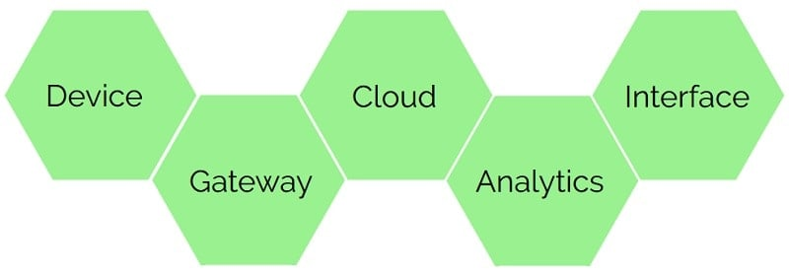

There are many topographies of how a sound IoT system should look. They all share the same idea – it all starts with the device or thing which generates and provides the data. Data from one or multiple devices are gathered, aggregated and sent to storage or cloud service. Probably one of the most critical elements of IoT is Analytic. Analytics tools incorporate all possible ways, including statistics, machine learning, big data technologies to make data understandable and use-able. This data can then be accessed through the user interface. User should have the ability not only to see the information but also alter it and even control the devices and actuators if needed.

Our Project

for our project we use the (Arduino) is an open-source electronics platform based on easy-to-use hardware and software. Arduino boards are able to read inputs - light on a sensor, a finger on a button, or a Twitter message - and turn it into an output - activating a motor, turning on an LED, publishing something online.

In our project we will use the Arduino as the micro controllers to control the water filling system

Also we use ultrasonic sensor , moisture sensor and relay to control the pump and bread board

The Implement of the Project:-

Arduino connecting
first we will connect the jump wire to the following pins:-
one will connect to the 5v and we will put it in the bread board.
One will connect to the GND and we will put it in the bread board.
One will connect to the Digital13.
One will connect to the Digital8.
One will connect to the Digital7.
One will connect to the PWM9.

As showing on the picture below.
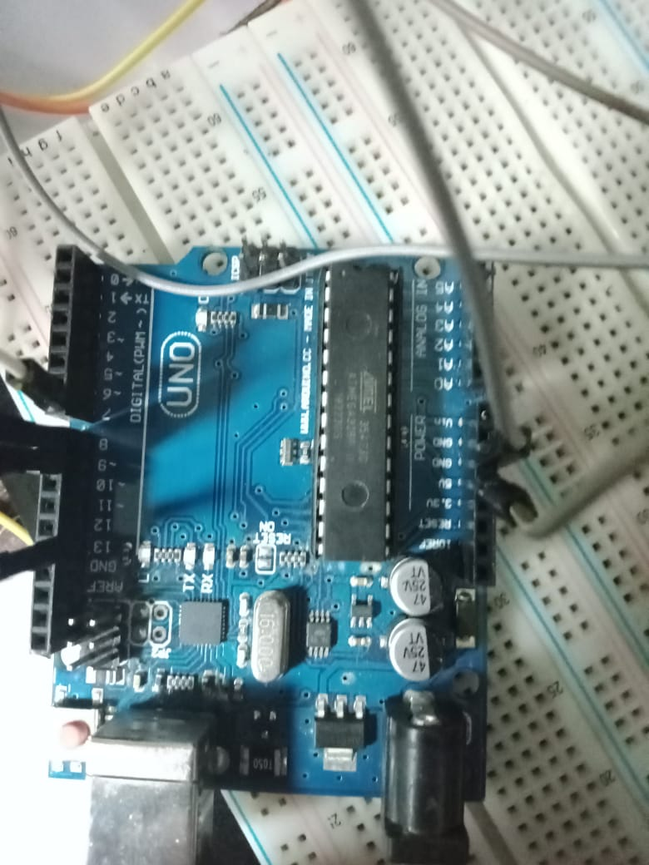

ultrasonic Connecting
we will connect the jump wire into following pins:-
the wire of 5v in the Arduino will connect into the VCC of the bread board.
The wire of GND will connect into the GND of the bread board.
The wire of PWM 9 on the arduino will connect into the Trig in the ultrasonic.
The wire of Digital8 will connect into the echo of the ultrasonic.

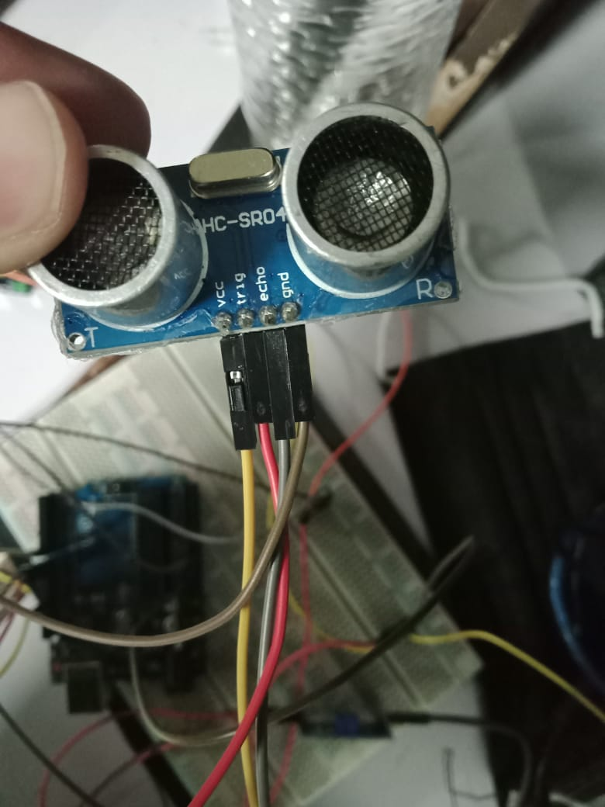

Moisture sensor Connecting
we will connect the jump wire into following pins:-
in the moisture we will use the digital instead of the analog because we need to check if there is water in the pipe or not
the wire of 5v in the Arduino will connect into the VCC of the bread board.
The wire of GND will connect into the GND of the bread board.
The wire of digital13 on the arduino will connect into the DO in the moisture.

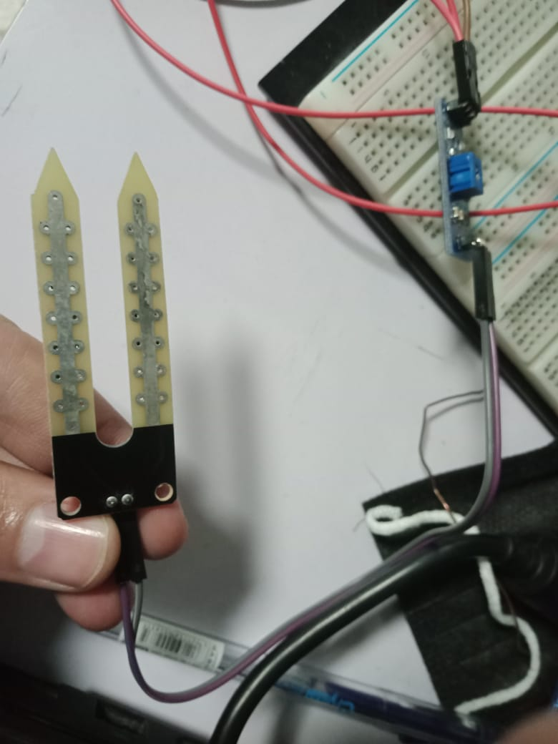 | 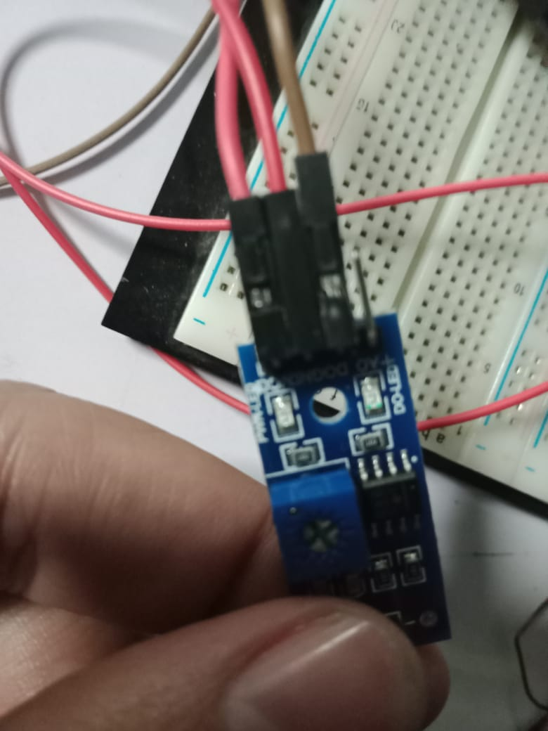

On the other side of the relays connection
in the Digital 7 we will connect the IN .
and for the GND relay in the GND on the bread board.
The com will connect to the pump that will open the water to the tank.

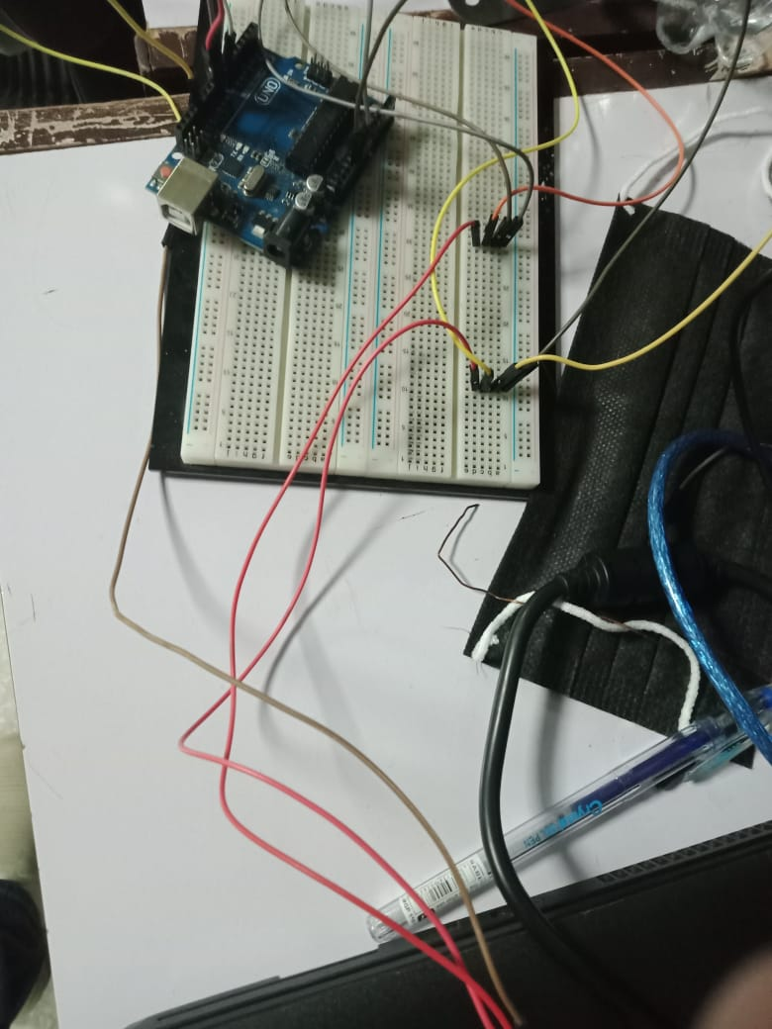

after that we will need the code to implement inside the Arduino.
(you can fined the code in git hub link(https://github.com/anas-dev-92/Water-Tank-Filling.git )).

Conclusion:
in this simple project we implement the way of controlling the water tank filling by using the Arduino .

also we can improve the project by exchange (water flow sensor instead of the moisture sensor) or if we want to add more sensor or screen to see the measurement of the water and filling level.

